# The Algorithm

Define

We reduce this to a max flow problem, where one unit of flow means one interview. We construct a graph. There is a source , sink , and three layers between.

1. The first layer has nodes for the candidates
2. the second layer has nodes for the recruiters and their available timeslots
3. the third layer has nodes for the recruiters
4. There is a directed edge of capacity from to every node in the first layer
5. There is a directed edge of capacity from the first to second layer if recruiter is qualified to interview candidate and candidate is available at timeslot
6. There is a directed edge of capacity from the second to third layer for all recruiters .
7. There is a directed edge of capacity (recruiter ’s interviewing capacity) for all recruiters .

Run Ford-Fulkerson on this graph. If the max flow is less than the number of candidates , then there is no interview schedule where every candidate gets interviewed; if the max flow is equal to , then there is.

Example: there are three candidates: and . There are two recruiters: and . could be interviewed by and and is available at 10 AM and 1 PM. could be interviewed by and is available at 10 AM and 2 PM. could be interviewed by and is available at 1 PM. has capacity 3 and is available at 10 AM and 2 PM. has capacity 2 and is available at 10 AM and 1 PM. The constructed graph for this problem would look as such: 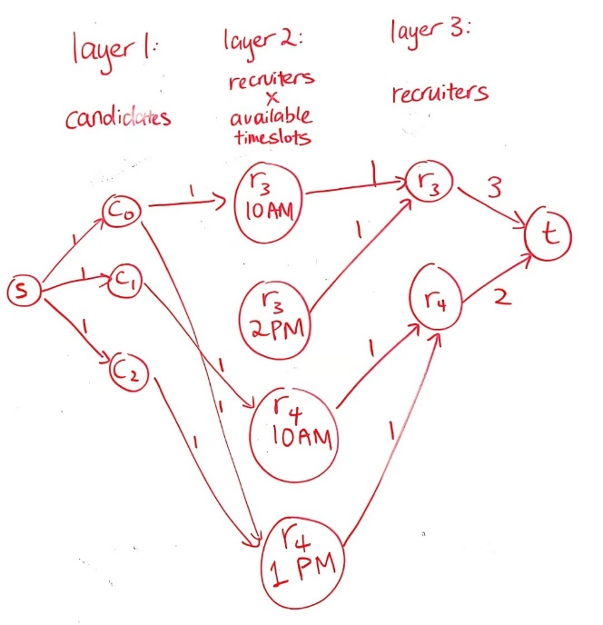

# Proof of Correctness

This problem is under several constraints:

1. Each candidate gets at most 1 interview

This is satisfied by the edges from layer to layer 1, which all have capacity 1.

1. Each candidate can only be interviewed at a timeslot he is available for

This is satisfied by the edges from layer 1 to layer 2, which only exist if the candidate is available at the time slot the edge is connecting him to

1. Each candidate can only be interviewed by qualified recruiters

This is also satisfied by the edges from layer 1 to layer 2, which only exist if the recruiter is qualified to interview the candidate the edge is connecting her to

1. Each recruiter conducts at most interviews

This is satisfied by the edges from layer 3 to , which have capacities

1. Each recruiter can only conduct interviews at timeslots she is available for

This is satisfied by the layer 2 itself, where each node only exists if recruiter is available at timeslot .

1. Each timeslot can have multiple interviews, but they must be of different recruiters *and* different candidates, i.e. a timeslot can’t have one recruiter interviewing more than one candidate and a timeslot can’t have a candidate interviewed by more than one recruiter.

This is satisfied by the edges between layers 1 and 3 all having capacities 1, meaning if a flow of value 1 goes into a node in layer 2, then only 1 can flow out (thus one candidate only has one recruiter), and if a flow of value 1 goes out from layer 2, that means a flow of 1 went in (thus one recruiter only interviews one candidate)

# Runtime Analysis

The runtime of Ford-Fulkerson is , where is the number of edges in the graph and is the sum of the capacities of all edges leaving the source. here is . here is , This algorithm is thus , which is polynomial is all the variables involved.